IN MEMORIAM

RICHARD EDWARD CURTIS

14th April 1936 - 30th September 2016

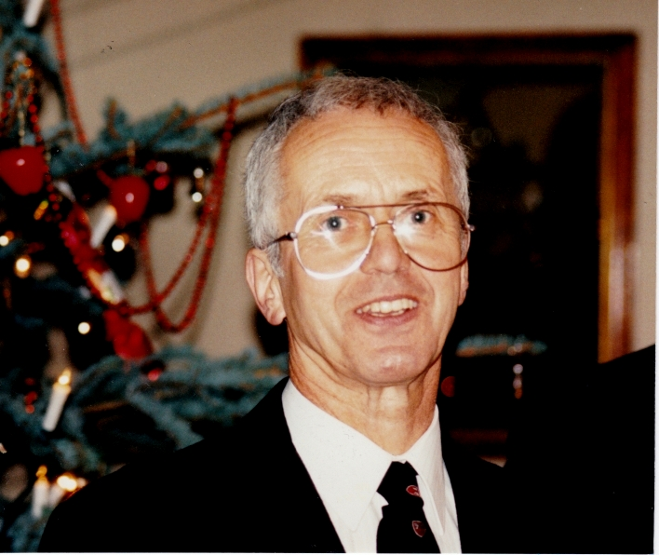

Anoyia, Crete (Richard Curtis)

TABLE OF CONTENTS
A. EULOGY 3
B. EARLY DAYS 5
Richard as an art student 5
C. KYNASTON SCHOOL and QUINTIN KYNASTON 6
Len Clark, teacher 6
Gerry Brennan, teacher 6
Tributes from pupils 7
D. THE TRAVELLER 9
Globe Trotters Club 9
From Neil Edington 9
From Chris Horner 10
From Another Traveller 10
From Peter Harrison, Melbourne 11
E. WASPISH 13
From Wasps Rugby Club 13
Tribute from Waheed Aslam, Wasps FC 15
From Wasp supporters on Drunken Wasps web site 15

EULOGY

RICHARD EDWARD CURTIS

So many here, from so many perspectives ... we are here to celebrate the long and generous life of this unusual spirit as he would have wished had he not been so modest.
I have not much time today you will be glad to hear but have assembled the many contributions sent to me in a file which will fill in the gaps I hope.
I have known Richard since about 1962 ... Janie my wife longer as they were both brought up in Wimborne Minster in Dorset as small children ...
He was born in 1936, went to Wimborne Grammar School then to Poole Art College after doing his National Service in the Air Force.
In 1960 or so he joined what was the Quintin Grammar School in St John’s Wood as an arts master, soon became Head of that department. Later it merged with Kynaston Technical School, became the comprehensive Quintin Kynaston and recently morphed into an academy. Richard was there until he retired in 1997.
All very conventional ... but not really so. He was a modest man but under this facade lay rare talents which enabled him to contribute in different spheres of life, as your presence today attests.
The 40 years at Quintin Kynaston were the initial core of his life.
As a teacher and an artist, Dick was a perfectionist. Every summer the School art exhibition celebrated the works of the students, notable by their quality. His lessons were not just about drawing and painting. They spread to photography and printmaking and other areas.
His enthusiasm was infectious and his pupils often worked long after the school day had finished. He set up a printing club which met after school and at lunchtime.
He persuaded the Headmaster to close the school for one day so the 900 pupils and staff could do some orienteering outside London! He abseiled down the 6 storeys of the school for charity. He took pupils walking in the Welsh mountains. He made a large sculpture of an angel one Xmas for the roof of the school. And much more.
Dick was an inspirational teacher who nurtured talented students and in addition took a particular interest in individuals who were struggling in one way or another. A team builder, he helped many young people find their way through the difficult years of adolescence by helping them to identify achievable goals and search out things that interested them.
Many developed distinguished careers in later life.
The second overlapping strand in his life was travelling. He made himself a one man tent and went everywhere on a shoestring. Greece, Holland, Texas, Thailand, Ladakh, China, New Zealand, I lose count. Once he showed me some astonishing photographs taken in the Yemen - remarkable buildings in Sana’a alas largely destroyed by Saudi Arabia this year.
This strand led him to the Globe Trotters, a club of unorthodox travellers, people who bicycle across a Asia, or pull a sleigh through Alaska. They meet once a month and one of the travellers will give a fascinating talk about his extravaganza.
For about 10 years Dick organised its speakers, which involved planning at least 6 months ahead. He built a folding stand for exhibitions, was its driving force in that period.
One year he went to Crete, with my family. We went to a little village called Xoro Sfakion on the south coast and I left him with his rucksack on a path to the North of the island through the White Mountains, 2,400m of barren rock. A week or two later there was a news item in a local paper about a wild Englishman who had arrived starving in a small village on the Southern slope, covered in blood ... he had lost the path and clambered down a gorge which gradually steepened and from which he could not turn back ... typical Dick!
In 1997 he and I flew to Nepal to walk around Annapurna. We met the night before at his flat. Dick was staring at three pairs of boots on the floor.
“Which will you take?”
“I haven’t decided yet”
The next night in Katmandu, curious, I asked which pair he had chosen. He unpacked his bag ... he had not decided and all three pairs were there!
Suddenly I understood why he had not married - he could never decide about that either ...
Even after a fall resulting in a hip replacement his love of the outdoor was not curtailed. He continued to take part in regular walks organised by Chris Horner (although Dick inevitably tried to reorganise them!), and also still organised his own annual ritual walk to celebrate the Chinese New Year, with its stops at suitable pubs.
In 1992 or so a games master took him to Sudbury for a Wasps rugby match.
This became the third strand of his life and he asked to be cremated wearing a Wasps shirt and his favourite walking trousers!
He designed shirts and hats for Wasps, attended all their matches, here and abroad, supplied its web site with wonderful photographs after each match, contributed waspish comments under the alias of Drunken Wasp.
He used his design skills to volunteer advice on buildings, adverts and anything else that interested him both with the professional and the amateur Wasps sides but also the Olympics. Nothing was out of scope.
He was full of ideas – some practical, others less so. At the beginning of every season, Wasps’ office staff knew that they could look forward to the latest raft of Dixie ideas.
Once he had an idea for about a fund raising event. It involved hundreds of people going the wrong way up escalators in City office blocks. The following day, he emailed detailed, colour-coded flow charts, to show exactly how it would work. Not surprisingly, it never got off the ground.
The weekend before he passed away, Wasps notched a memorable victory at Northampton. His doctor recorded the game onto his laptop and brought it in for Dick to watch.
I often think of Dick as an aquifer, a hidden resource which over the years has watered so many disparate streams, so many of us.
He returned to Crete many times, made friends in remote places. One was a village called Anoyia. He was befriended by a local poet singer and composer called Ludovico who later became very well known. The song you will hear at the end of this occasion is Dick’s favourite. Its title is:

“What is the colour of love?”

We celebrate him and we shall not forget him.
George Roussopoulos

EARLY DAYS

He was born in Ringwood, his parents were Irving John Curtis and Jane (nee Millicent). His father had small farm in the area then moved to Wimborne Minster after the war. He attended Wimborne Grammar School, did his National Service in the Air Force then went to the Poole Art College.

Richard as an art student

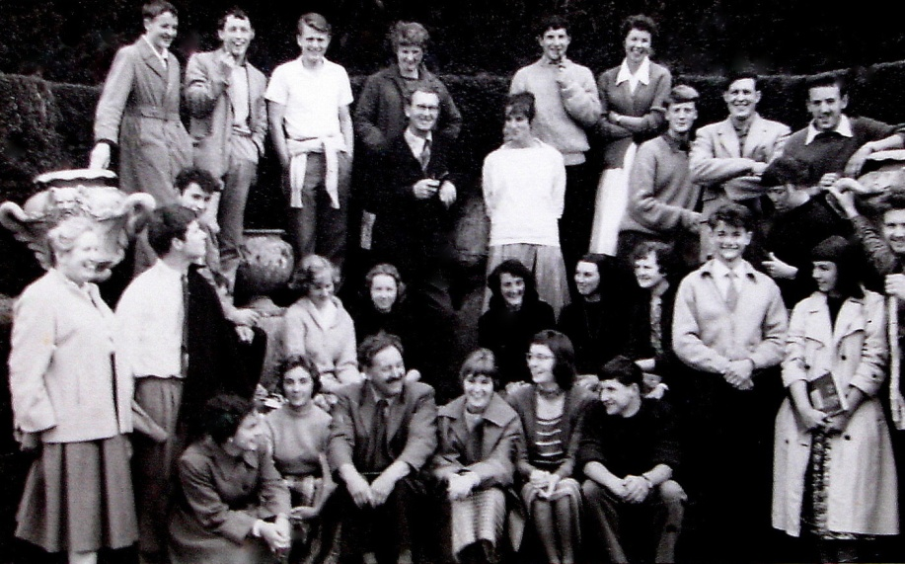
Poole College group 1957

Our memories of Richard as an Art Student - well true to form he was as always an organiser and armed with his camera he was our unofficial recorder of events, such as the art school ‘Hops’ and exhibitions.
He became the treasurer of the student club, we handed him sixpence a week. The money collected subsidised an outing each term, covering the coach hire, usually a Bere Regis coach which we always filled, and theatre tickets. London was the main attraction - an exhibition during the day and the theatre in the evening. We saw some great shows - West Side Story, and South Pacific with Mary Martin washing her hair on stage, Guys and Dolls with Stubby Kays and his famous rendering of ’Sit Down you’re Rocking The Boat’. As you can imagine we did a lot of singing on the way home!
Our potter friend Warwick attended Wimborne Grammar School and remembers how Richard climbed above the stage and fixed a string which he lowered while the headmaster was taking assembly. When the headmaster realised what the giggling was about two prefects were ordered to find the culprit, Richard escaped and the culprit was never found - typical!
We all agree, (Dorset friends included) that Richard was a mischievous individual, naughty but nice, always with a plan, an idea, a solution. He will be sadly missed.
Jan and Mike Hart

KYNASTON SCHOOL and QUINTIN KYNASTON

Len Clark, teacher
I started teaching at Kynaston School in July 1958 and Dick was appointed to the Art Department a year or two later – I can’t remember precisely when, but then neither could he! It wasn’t too long after that that the Head of Department took early retirement and Dick was the obvious person to take his place for he had already proved to be a very valuable colleague. His two loves were his subject and teaching and he was very gifted in both of those fields and passionate about them. When Kynaston School was merged with Quintin some ten years or so later I’m pretty sure that it was Dick who became Head of Department in the new set-up.
Dick’s lessons weren’t just about painting and drawing, they included printing and photography, indeed pretty well all aspects of Art and his enthusiasm for his subject was infectious as far as his pupils were concerned and they were often to be found working away in the art department long after the school day had finished. He set up a printing club which met after school and at lunchtime and as a result a number of pupils found their way into the printing trade when they left school.
He played a full part in the life of the school and at one point organised a sort of orienteering exercise which involved all 900 or so pupils and the staff in spending a day exploring and walking outside London – he persuaded the Headmaster to close the school for a day so that this exercise could take place. On one occasion I seem to remember he abseiled down the side of the school which was a building of six storeys – I think was done for charity. One Christmas he made a large sculpture of an angel which he proudly set up on the roof of the school by the side of the Finchley Road.
I moved on to another school in 1975 but I believe that Dick carried on there until he retired which would probably have been around the turn of the century which meant that the whole of his teaching career was spent teaching at one school.

Gerry Brennan, teacher
Dick was the Head of Art when I joined the department at QK (Quintin Kynaston School) in September 1986. We worked together for two years before I moved on to another school in 1988.
I was in my first year of teaching and I learnt all I needed to know about various printmaking processes from him. Most importantly I learnt the art of silencing a whole class without saying a word beyond ‘….are we ready to start the lesson’? It was all about how you surveyed the room at the same time while settling your gaze on anyone who was not paying attention. He was always so patient and kind with his students that bad behaviour in any form was intolerable to him.
As a teacher and an artist, Dick was a perfectionist and always encouraged students to achieve their best. Every summer the School art exhibition celebrated the very high quality Art and Printmaking works produced by the students.
Dick was an inspirational teacher who nurtured talented students and in addition took a particular interest in individuals who were struggling in one way or another. Apart from the art club after school hours that enabled students to do extra work and boost their achievement, he encouraged many of them to take part in walking and camping adventures, which he believed developed their self confidence and independence as young people. If there were some hardships involved (such as poor weather conditions) all the better as he thought this helped to build resilience.
Dick was a team builder and helped many young people find their way through the difficult years of adolescence. By helping them to identify achievable goals and search out things that interested them, the students responded positively.
One of the things I personally respected about Dick as a teacher and colleague, was the way that he was ‘gender blind’ in a positive way. He would never discriminate between the boys and the girls when it came to setting out challenges to tackle. Whether it was an educational task or a camping / walking challenge, he saw both groups as equal to the task.
Dick loved to travel and loved being outdoors and shared these enthusiasms with his students and colleagues. After leaving QK, we kept in touch over the years, through our shared interests in the Art world, Art Education, world travel and walking.
Every year in December Dick would organise a QK gathering of present and past staff to see the pantomime at Stratford East Theatre in London. This was another enthusiasm he shared with others.
He will be greatly missed by all who knew his very unique personality and goodness.

Tributes from pupils

Greatest sympathy with him and his family for this sad news .... I told my daughter this sad news because she was also taught by him years later…! and she had the fondest memories of him and remarked on his own wonderful detailed drawings which I myself never saw.
Richard and Maya Crowe
I was lucky to be taught by Dick and also attended his after school art club where he patiently taught me about silk screen printing and poster design. Though never much as an artist I have continued to be interested in art ever since.
I have a few Kynaston bits and would be pleased to share them with any archive if they are needed.
Rod Macleod
Richard Crowe and I spent two wonderful hours with Dick CURTIS this afternoon. He was very happy to see us and we had enjoyable and very moving chats about his memories and ours.
All remember Kynaston with affection and pride. I recited the warm messages from several people including Roddy, Aitor, Sam, Marten, Andy VALDAR, Andy Laskos, and John Pike and Michael Hall. Dick was moved visibly -- quite frankly so were we!
We had the pleasure of meeting Dick's long-time friend who was also a teacher at Kynaston who advised of his illness.
Pradeep Chand
Thanks for informing us. May God bless his soul and give it peace. A wonderful human being. Glad I was there last Sunday, he was in good spirits. Please do let us know the funeral arrangements-- will do my best to come.
Please ask Gerry to give our sincere condolences to all family and friends. Remembering Dick with respect and admiration
Pradeep Chand
Thank you for informing us of this very sad news. It’s rather hard to take in as he seemed so lively and full of mental energy when Pradeep and I saw him just such a little while past.
I am very glad we did and acted quickly in this as it has all happened so fast. I was in London briefly almost by chance and for such a short time and I am deeply grateful to the fates that we had that brief few hours in that pleasant room he was in. Our meeting that afternoon left us both I think deeply touched and Dick was in such fine form. We laughed, we remembered and it seemed in no time all those days ago seemed like yesterday. Far from seeming tragic Dick's spirit just lifted us. A joyous memory.
Richard Crowe
Thank you for passing on the very sad news. Chris and I are pleased that we saw him earlier in the week but he was obviously fading and we can only be grateful that he didn't seem to have been in pain and passed peacefully in his sleep.
I have a great deal to be grateful to him for. Please pass on our condolences to his family and let us know the funeral arrangements.
‘Tug’ (Tony Tugwell)
Such sad news, even though expected as, when Tony and I visited he was his normal positive, talkative self. A lovely chap who was a great teacher and someone I shall remember with affection and gratitude. I do so hope that I can make it to the funeral.
In sadness
Marten Collins
Really sad news. I am glad that in his last few days he clearly enjoyed the meetings with several of you.
He was a lovely man who enriched many lives.
Andy Valdar
Dear All – I can only add to everyone’s comments of loss and sadness at Dick’s passing. I did not know Dick when I was at Kynaston and only briefly met him at our “get–togethers”. I am clear though that he was a much respected and loved teacher who added to and maybe changed for the good many young lives – what a tremendous legacy and outcome for his career in teaching and life well lived.
John Pike
Very sad to hear that Dick has passed away. He was a fantastic teacher and human being who will be sadly missed. I was fortunate enough to be one his pupil and to join the teaching profession. I will miss him greatly, as so will many others.
My condolences to friends and family.
Aitor Chamberlain
Dick arrived at Kynaston in the late 50s, and wasn't directly involved with my particular class -- the original boys of '56. Through the school plays and various activities, we came in contact, and I always regretted that we didn't have classes or a closer relationship with him. He was obviously a very fine art teacher and someone who cared about his boys, a quality that he kept right up until the end.
Through the school reunions of last year, I made email contact with him, and we exchanged quite a few notes and photos and end-of-year newsletters. He was particularly engaged by the visit to Australia which my wife and I made last December-January, and he shared his own memories of trips there, along with suggestions for places and people to see. I had a sense, from the way he talked about some of his solitary epic treks in the wilderness of several countries that he was a man in search of some unknowable destination -- perhaps himself, if that's not too heavy a speculation.
Dick could have a bit of an edge to him, and the one subject guaranteed to set him off was the official history of Q-K, which is just plain awful and wrong in the way it describes the beginning years of Kynaston. As must be true of many of our teachers (though not all!), the Kynaston years must have been at the heart of his professional life, and they meant a great deal to him.
Unfortunately I cannot come to the funeral but the outpouring of emails from his students, taken together, are like one of Dick's own canvases -- full of warmth and many colours. This was a man who affected lives.
Andrew Laskos (Hollywood, California)

THE TRAVELLER

Dick’s love of travel started when he took parties from Quintin Kynaston school to Wales and Europe in the 1960ies. He then made himself a one man tent that he carried around the world: Yemen, Crete, Ladakh, Sarawak, Australia, US, Nepal, China, India and more.
In Crete, to which he was particularly attached, he gave an exhibition of his own photographs at the Yakinthos Festival near Anoyia which had been founded by his friend Ludoviko Ton Anoyias: " Anogia 80s "the artist - photographer Dick Kourtis”.

Globe Trotters Club

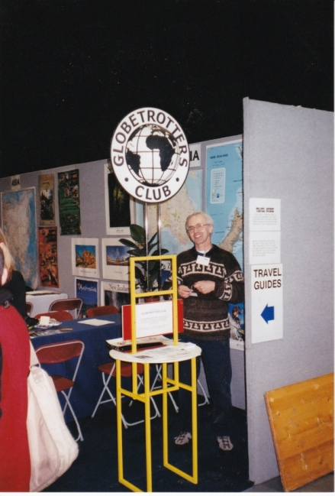
The Globe Trotters Club for unconventional travellers was founded in the 1940ies. At its monthly meetings in London, travellers with unusual stories talk about their journeys - not celebrities, just ordinary people. It also acts as an information and contact centre for those who might be planning some difficult trip through neglected parts of the globe or with imaginative means of transport.
One day Dick saw an ad in Time Out about a lecture and joined Globies probably in the 1980ies.
His contributions to Globies were deep, too numerous to list them all here.
In 1993 he took over organising its meetings, finding speakers nearly a year ahead and occasionally talking himself. He only handed that over in 2008.
He booked the speakers (sending handwritten calligraphic letters), the hall and did little publicity runs around various bookshops, the RGS, etc. making and printing up flyers.
He designed and made the travel show stands (see photo), a folding lectern for speakers, won the 2016 Globetrotters calendar competition.
Dick’s own talks were infectious - vibrant and informed, often somewhat quirky. Who else would show us arty patterns in London pavements? He loved life & meeting people from all walks of life, always offering a helpful remark on how to get things done.
His interest however was not confined to the outside world. His intimate knowledge of London was formed through extensive walks and he shared this enthusiasm with his friends from abroad, often took groups of members of Globies with him.
He will be missed by all members.
Contributions from Paul Roberts Simon, Sarah Chanter

From Neil Edington
I first met Dick at a yoga class over thirty years ago when he was back from one of his Himalayan walkabouts - we both were supporters of children at The Druk White Lotus School in Ladakh. Sylvia Prescot was our inspired yoga teacher, and when she retired we found her difficult to replace, so we transposed into playing badminton on a weekly basis, with the similarity to yoga inasmuch as we retired to the pub afterwards.
Dick had played badminton for many years, while I had dabbled at tennis and squash, but never badminton. You will not be suprised that Dick was very good at putting me through his paces, and, most of the time, he won the matches!
The years of this fun ended when he woke to find a burglar in his bedroom one evening and, in leaping out of bed to chase the burglar (caught by CCTV!), he fell and fractured his hip. As it was me he rang from Paddington hospital I ended up being a major carer for that chapter of his life, and thus designated in this his final chapter..... but this final chapter very much shared with his loyal, fellow rugby supporter, Alistair. I also know that Dick very much appreciated all the other visitors who came to cheer him up... thankyou.
Even after the broken hip we continued to meet almost every month to catch up on life, usually over a pint,.... to sort out the world,....his life; discuss the progress of Wasps (a new set of topics for me to learn!), and to have the privilege of looking at his latest set of life drawings from his Thursday afternoon classes.
It was an unexpected and special friendship which I shall certainly miss. I applaud all the complimentary things that you have all said about him: he enriched all our lives. May he rest in peace.

From Chris Horner
I was lucky enough to meet Dick over 40 years ago during a walking weekend in Wales. He was an avid walker and his enthusiasm so infected me that we continued to walk regularly together as late as this spring.
A high spot each February were his legendary Chinese New Year Walks, starting always in Marlow, lunching at The Crown in Skirmett (no longer a pub sadly) and finishing at Hambledon. They began in the 70ies and continued well into this century.
And then there were his pantomime evenings at Stratford East and his truly amazing Christmas cards.
He was a man who made the most of life and shared it with his many friends. It was a pleasure to have known him and he will be sorely missed.
Chris Horner

From Another Traveller
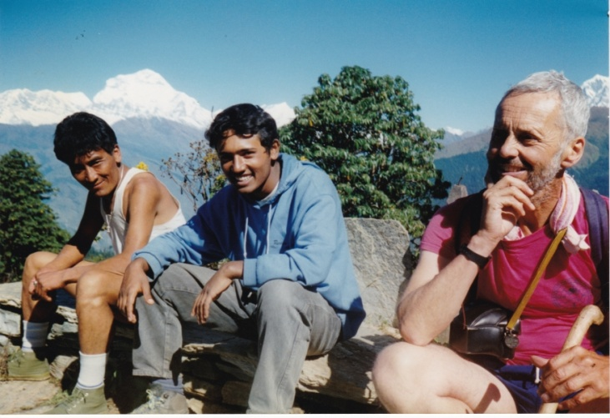
Thank you Alistair, for sending the sad news about Dick.
As a Dutchman I will have trouble to express my feelings in English. But I’m going to try anyway.
I met Dick in 1984 while traveling in China. He was doing the same, two European guys in a complete other world. We traveled a week or so together, witch was very nice. But he went to Hong Kong, I was going to Tibet.
A year later I visited him in Londen for a couple of days. He showed me London, and I think he was very good in doing that! Later he came to Utrecht, Holland. He liked the city. That was with New Year. Here in Holland we always have a very big firework all over the country.
Dutch people spend many millions every year on that firework. At midnight we were standing for my window, looking over the city to see the firework. After a few minutes, after already thausands of loud bangs and flashes of rockets, Dick said: Is a war going on here?
A few years later I was in England to visit Dick. We went to Fishguard, stayed in a house of a friend of Dick. And it was New Year again. And again at midnight we were standing for the window to oversee Fishguard.There was 1 (one) rocket only in the sky. Dick waited for 30 seconds and said: Wauw!
I liked Dick very much, he was a very nice guy with a very good sence of humor. And he was an exellent London guide. We exchanged much together, he was an art teacher, I was graphic designer. And I sent him many travel photos, he liked my photos always very nice.
Every year he send me a brilliant Christmas & New Year letter. I will miss that letters, I will miss Dick.
I’m afraid that I am too old, it will be too complicated for me to come to London for the funeral. But please keep me informed anyway. I will be with my thoughts with Dick.
Dick mentioned many years ago a sister. If she still is alive, or anyone else of the family, please send this to her or them. Or read it for the ceremony, if it is worth it.
Again thank for your message
Rob van Erp

From Peter Harrison, Melbourne
Like all of you I'm sure, I was shocked and deeply saddened to hear of Richard's death.
My parents Stuart and Ida Harrison in Melbourne Australia first had contact with Dick in late 1973 when they were planning their retirement trip through Europe. Tragically, my older sister Anne aged 24 died in a river accident on eve of their departure. Stuart and Ida undertook their trip a year later and stayed at his flat, using it as a home. Anne's friend Elspeth Stephens was with. Dick kept in contact with Elspeth and my parents from that day onwards. It is not hard to imagine the kindness and compassion he would have extended to my parents during that time. He later travelled to Australia, visited my parents, joined me in a short tour around western Victoria.
In 1979 and 1980 I spent time in UK myself, and Dick was ever considerate and supportive of me, as I was a rather troubled youth during those years. For some bizarre reason I remember our first meeting at his flat in Hampstead, when he opened the door with a wrench in his hand saying "Come in, I'm just in the middle of fixing the cistern of the toilet!" I remember him showing me around the art department in his school, having a curry and a pint with friends at the local pub, walking around London streets, and hearing about his many trips through Europe.
My father died in 1985 and my mother in 1998. They never failed to receive amazing Christmas cards/newsletters from Dick, sometimes accompanied by lovely sketches of some far-flung scene from his latest trip.
I was in London in 2014/15. We walked through the docklands, admiring and sometimes lamenting the architecture, with animated discussion about the world around us - typical of the deep and considered thinker that he was.
This is the thing - it is sometimes easy to take it for granted that a friend afar is always going to be there... and then they are not. Richard, At the time of writing, I don't know what took you. I just know that you are gone. So very sad to have lost you to this life.
Thank you Richard for how you looked after my parents and myself all those years ago, and for your friendship ever since. You have been, and in our hearts will always be a wonderfully considerate, deep-thinking, artistically-talented and genuine friend to us.

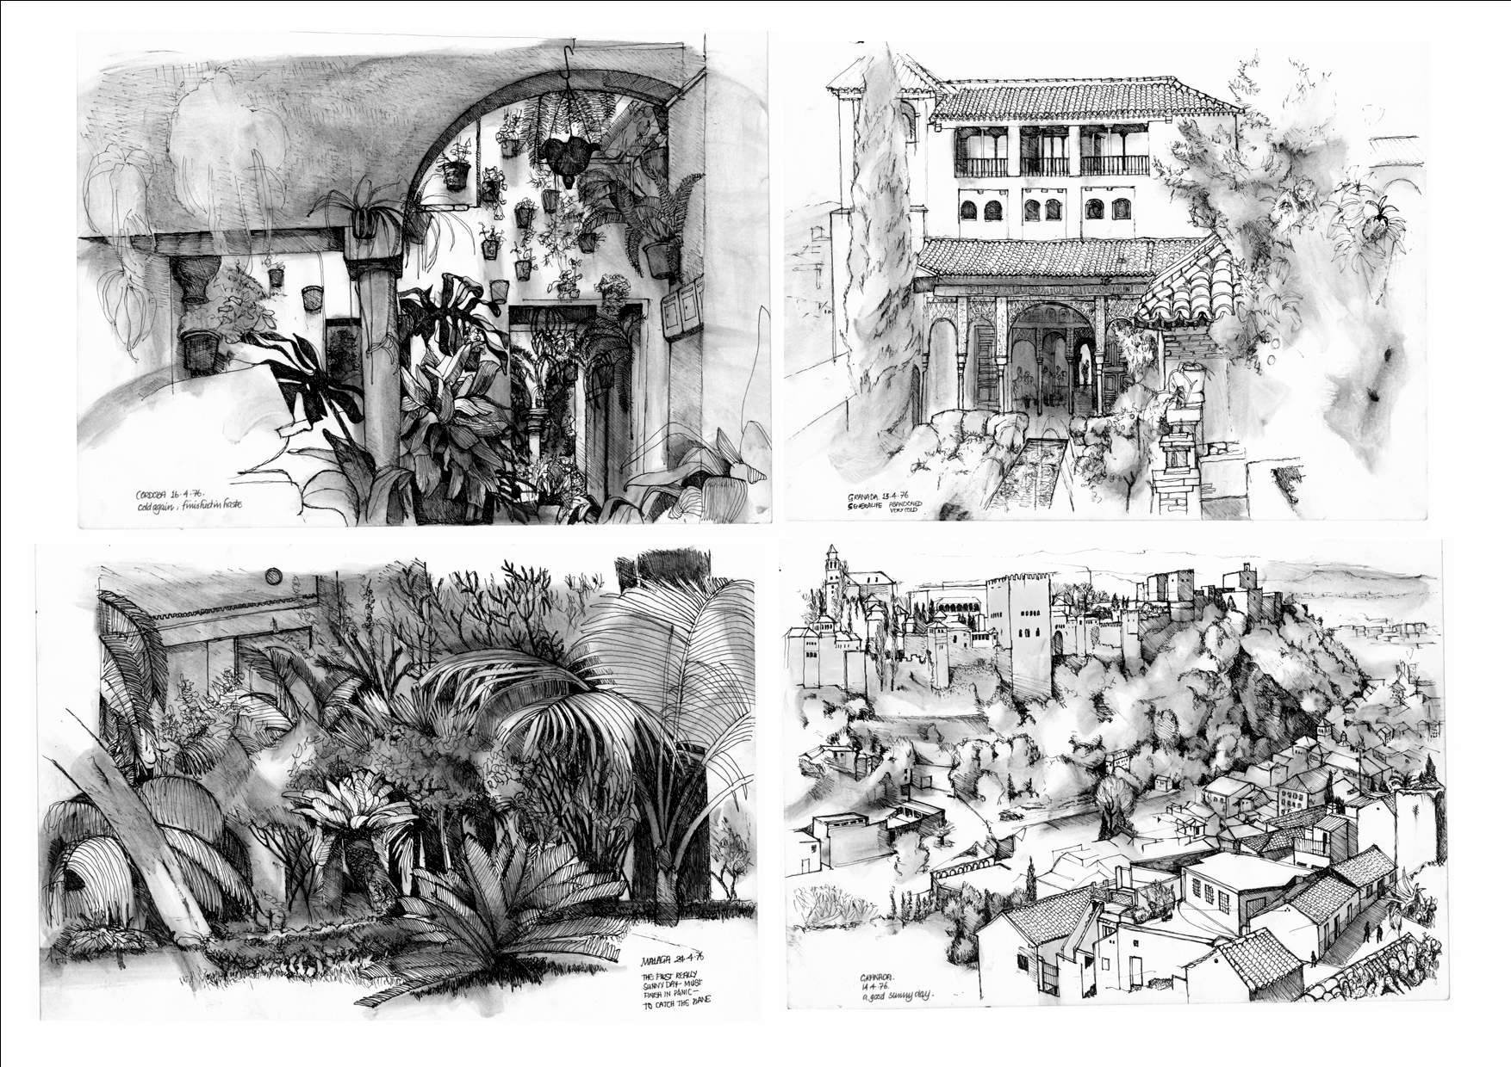
Drawings from Spain, Easter 1976 (Richard Curtis)

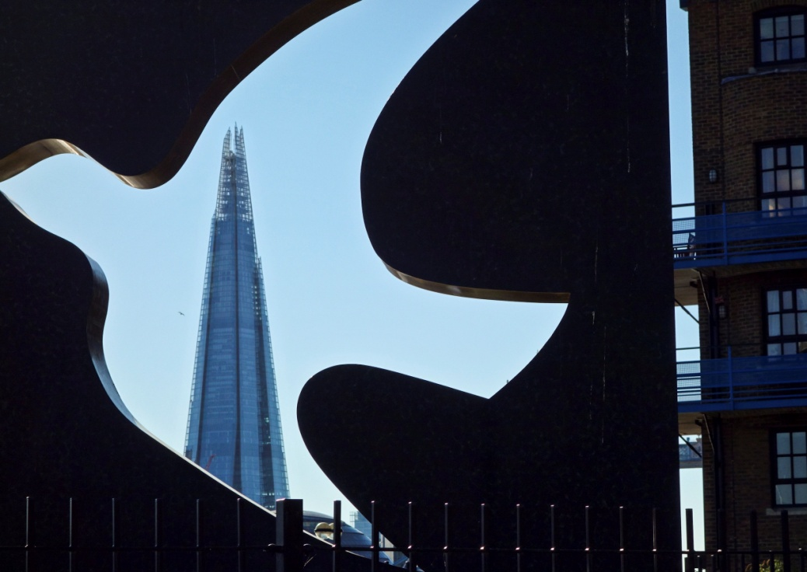
The Shard, London 2015 by RC

WASPISH

From Wasps Rugby Club

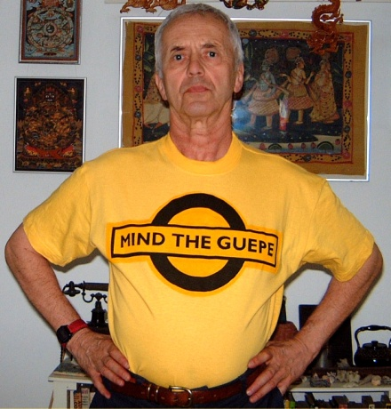
Richard ‘Dick’ Curtis (AKA Dixie) was as passionate a Wasps supporter as has ever drawn breath. An art and design teacher by profession, he spent his entire working life at the same school in northwest London, living in a flat full of furniture he designed and built himself.
After a colleague took him along to Sudbury, Wasps soon became one of the loves of his life. He was an instantly recognisable figure, wearing an eye-catching range of Wasps gear which was his own creation.
He was well known by supporters of all the Premiership clubs, with his diligently researched “Waspie Welcome” unfailingly being published online, to help all visiting fans make the most of their trip to Wasps territory. He would religiously pore through media websites, identifying stories for inclusion in the comprehensive “Dixie Daily”, which appeared without fail, on the Wasps’ supporters site.
An inveterate independent traveller, he came into his own when Wasps were playing in Europe. Once he had retired, he would invariably set off several days before the rest of the travelling support, and reach his destination via a combination of imaginative routes. It was routinely joked that he travelled by night bus, tramp steamer, mule train, glider, Romany caravan and various other unconventional modes of transport. He also favoured ‘interesting’ places to stay. Only Dick could book himself into a Bayonne hotel which was on the verge of being demolished around him.
Once he was there, he would immediately get to know his new surroundings. On one trip to Perpignan, I was greeted on arrival by Dick, who immediately filled me in on all I needed to know about the local Highland Dance Society. It became another standing joke that he could recommend the best goat stew in town, served in the latest back-street eatery he’d stumbled across.
As befits a man of his profession, he was full of ideas – some practical, others less so. At the beginning of every season, Wasps’ office staff knew that they could look forward to the latest raft of Dixie ideas.
When Dick approached you, with a determined glint in his eye, you knew that you would be there for some time. I still chuckle at the memory of the time he pounced on me and treated me to his latest brainchild, for a fundraising event. It involved hundreds of people going the wrong way up escalators in City office blocks. The following day, he emailed me detailed, colour-coded flow charts, to show exactly how it would work.
Not surprisingly, it never got off the ground.
He was as keen a supporter of Wasps FC, the amateurs, as he was of the professional outfit. I spent two years doing communications for the FC, which involved filling two pages of the London Wasps matchday programme. I could never have filled those pages without Dick sending me a steady stream of photographs of games involving all levels of Wasps FC.
Everybody has a Dixie story, usually involving him cornering them and letting them know, at great length, about the latest bee in his bonnet. One recurring bee was a nameless Premiership club. It was ironic that, in the last few weeks of his life, at a Marie Curie hospice, he was cared for by a doctor and two nurses who supported that particular club. The weekend before he passed away, Wasps notched a memorable victory at Northampton. That same doctor recorded the game onto his laptop and brought it in for Dick to watch.
Cheerman Dick reforms Adam Park in 2014
It was Dick who gave many Wasps supporters a memory they will cherish for ever, back in 2006. A supporters’ Curry Night had been organised, to support Alex King’s Benefit Season. The previous year, a similar night had been held for Will Green, and club chaplain David Chawner had said grace. David was not available, so a replacement had to be found. I suggested Dick, on the grounds that he looked vaguely beatific – I always felt that his standard expression resembled the way a bemused cherub might look.
The suggestion was approved, Dick was approached and he accepted the job. During the weeks leading up to the event, he frequently asked what exactly he had to do. He was told that all he needed to do was stand up, say grace, then sit down again.
On the night, he arrived , clutching a large file under his arm. It seemed to contain his life story. He showed it to MC Peter Scrivener. Scrivs, immediately seeing the comic potential, mischievously assured him that it was just what was needed.
At the appointed time, Dick stood up and strode forward to the podium. He proceeded to go through all the significant moments of his life and the journey which had taken him to Wasps. At one point, he summoned Alex King and asked him to kneel down, before placing a cardboard crown (made, of course, by his own hand) upon his head.
By the time he returned to his seat, he had been speaking for about twenty minutes, but had never actually got round to saying grace. Since that memorable night, he has frequently been reminded of his finest hour. He would always mutter that it had been the most embarrassing moment of his life, but would invariably be reassured that he had made a lot of people very happy. To this day, those who were there recall, with tears of laughter, the night that Dixie never said grace. Next time they stir those memories, the tears of laughter will be joined by a few tears of sadness.
The Wasps victory song goes: If you want to go to Heaven, when you die, wear a black and yellow bonnet, with Waspies written on it. Dick’s headgear may never have matched that description precisely, but the Dixie range of Waspiewear will certainly have passed muster with St.Peter. You can bet that Dick is already showing the coach of Heaven RFC his ideas for the next shirt, with Black and Gold featuring prominently.
He died peacefully, on the morning of September the 30th, with his beloved Wasps sitting proudly atop the Premiership table. Two days earlier, a fellow Wasps supporter had shared a beer with him in the hospice garden, which was bathed in autumn sunshine. He knew the end was near, but he was calm and in good spirits.
A gentleman and a gentle, kindly human being, Dick did not have a nasty bone in his body. He spent his entire life trying to do things to benefit others. He would be embarrassed to think that, for many years to come, Wasps supporters will be meeting and sharing affectionate Dixie memories.
Dick – you were a one-off and you will be missed far more than you could ever imagine. Thank you for sharing your love of Wasps with us and giving us so many memories to treasure. RIP, old friend. We shall be toasting your memory, as try to track down Toulouse's finest ragoût de chèvre!
Barney Burnham

Tribute from Waheed Aslam, Wasps FC
SAD NEWS : RIP Richard Curtis, aka Dick, aka Dixie Wasps
Today we mourn the passing of life long Wasps supporter Richard Curtis, to the fans on the terraces and the Drunken Wasps website he was simply known as Dixie
Dixie was 80 this April. He was a retired art and design teacher having spent his entire career at the same school in St Johns Wood. In the last few weeks he has received many messages from ex pupils thanking him for his inspiratonal teaching. He can count a film maker in LA and an editor of Vogue among his proteges.
He was introduced to Wasps at Sudbury by a games teacher. He instantly felt at home and followed them for nearly 70 years to Loftus Road, Wycombe and Coventry. He was a regular on the European trips. This follows one of his other hobbies, the globetrotters club. His passport has many stamps from every continent.
He used his design skills to volunteer advice on buildings, adverts and anything else that interested him both with the professional and the amateur Wasps sides but also the Olympics. Nothing was out of scope.
He had a great belief in giving the young as broad an opportunity and education as possible including an opportunity to try new things. He regularly took pupils on outward bound trips both in this country and abroad.
He supported Wasps FC minis and Youth sections through the years. On any weekend would see him in the stands watching the pros as well as at Twyford Ave watching Wasps FC mens and ladies amateur teams. He was the main club photographer and his work can be seen on the Wasps website.
He was diagnosed with cancer in late April this year and remained alert and cheerful. He enjoyed a glass of beer in the garden in the sunshine last Wednesday. His last few weeks were spent in the company of 2 Sarries fans with whom he shared great rugby stories.
The title "Once a wasp always a wasp" truly applies to the likes of Dixie. Our friend, you will be missed but your infectious love of Wasps will live on.

From Wasp supporters on Drunken Wasps web site
About 100 supporters reacted to the news of his illness and death on the web site. Here is a selection:

1) So pleased that Dixie has been honoured by the club with the article and mention at halftime yesterday. He got a big cheer from the crowd at the ground. RIP and thoughts with his friends and family.
2) Very sad news. Wonderful, wonderful man, a joy to be in his company and a true gentleman. RIP Dixie.
3) KevinO and I were both very sad to hear this news. We didn't know Dixie that well but he was omnipresent since we have been Wasps fans. He was ever cheerful, entertaining to talk to and always a gentleman. He was so completely Wasps, I reckon if you'd cut him in half, he'd have been hooped in black & gold all the way through, in the correct Pantone shade, of course!
4) Going to miss my chats with Dixie. Often met him early doors in Wycombe on matchdays, before he got the first bus to the ground. More enjoyable was bumping into him in some back street while on tour, where He would enlighten us on how he managed to get there, normally by a very obscure route. It was not unknown for the ever helpful Dixie to produce a printed hand out of what we needed to do while in that town and its environs.
One European match in Wycombe, we watched from the Legger as Dixie appeared to corral a group of Grenoble supporters over at the train station, when he had got them all, He drove his herd through the station carpark and across the main road to us in the Legger to ensure they were all properly greeted and looked after, before getting them on the shuttle bus to the ground.
Essex Wasp, He did walk all the way and was the first time I noted he did not look that well. To make the walk even more gallant was that his hip (?) had still not healed properly after he broke it, haven fallen over chasing a burglar out of his bedroom / house.
I expect my mind will still bump into him while away on tour.
It was a pleasure knowing you Dixie.
5) I am new at this posting game but thought I would log in and express my sorrow at Dixie's passing. I heard through the grapevine but since i dont do Facebook I have no way of contacting everyone.
Dixie was a legend and always made me feel better - win or lose a game of rugby. Such a true rugby person of the old club values I was brought up on. I enjoyed talking to him and trying to catch him out - I never did.
And yes I remember that first Curry night of many I went too - great times and great memories. Mellie - wasn't your son a scrum half?
Kind Regards and maybe catch up in 2017 at the HC reunion.
Leon
6) Like many people I never had the pleasure of meeting the man, I knew DixieWasp the poster. His obscure subject titles to threads kept many guessing as to the content of his posted links. He will certainly be missed every time I visit this site.
Be at peace Dixie.

